**CN-Simulation**

**SACHIN DSILVA**

**4NM20IS120**

**Code:fourth.cc**

#include "ns3/core-module.h"

#include "ns3/network-module.h"

#include "ns3/netanim-module.h"

#include "ns3/internet-module.h"

#include "ns3/point-to-point-module.h"

#include "ns3/applications-module.h"

#include "ns3/point-to-point-layout-module.h"

#include "ns3/netanim-module.h"

using namespace ns3;

int main ()

{

std::string animFile="fourth.xml";

PointToPointHelper pointToPoint;

pointToPoint.SetDeviceAttribute ("DataRate", StringValue ("5Mbps"));

pointToPoint.SetChannelAttribute ("Delay", StringValue ("2ms"));

PointToPointStarHelper star (8, pointToPoint); //8 nodes

InternetStackHelper internet;

star.InstallStack (internet);

star.AssignIpv4Addresses (Ipv4AddressHelper ("10.1.1.0", "255.255.255.0"));

Address hubLocalAddress (InetSocketAddress (Ipv4Address::GetAny (), 5000));

PacketSinkHelper packetSinkHelper ("ns3::TcpSocketFactory", hubLocalAddress);

ApplicationContainer hubApp = packetSinkHelper.Install (star.GetHub ());

hubApp.Start (Seconds (1.0));

hubApp.Stop (Seconds (10.0));

OnOffHelper onOffHelper ("ns3::TcpSocketFactory", Address ());

onOffHelper.SetAttribute ("OnTime", StringValue

("ns3::ConstantRandomVariable[Constant=1]"));

onOffHelper.SetAttribute ("OffTime", StringValue

("ns3::ConstantRandomVariable[Constant=0]"));

ApplicationContainer spokeApps;

for (uint32_t i = 0; i < star.SpokeCount (); ++i)

{

AddressValue remoteAddress (InetSocketAddress (star.GetHubIpv4Address (i),

50000)); // 50000 is the port number

onOffHelper.SetAttribute ("Remote", remoteAddress);

spokeApps.Add (onOffHelper.Install (star.GetSpokeNode (i)));

}

spokeApps.Start (Seconds (1.0));

spokeApps.Stop (Seconds (10.0));

Ipv4GlobalRoutingHelper::PopulateRoutingTables ();

pointToPoint.EnablePcapAll ("star");

AnimationInterface anim(animFile);

anim.SetConstantPosition(star.GetHub(),10.0,60.0);

Simulator::Run ();

Simulator::Destroy ();

return 0;

}

Output:

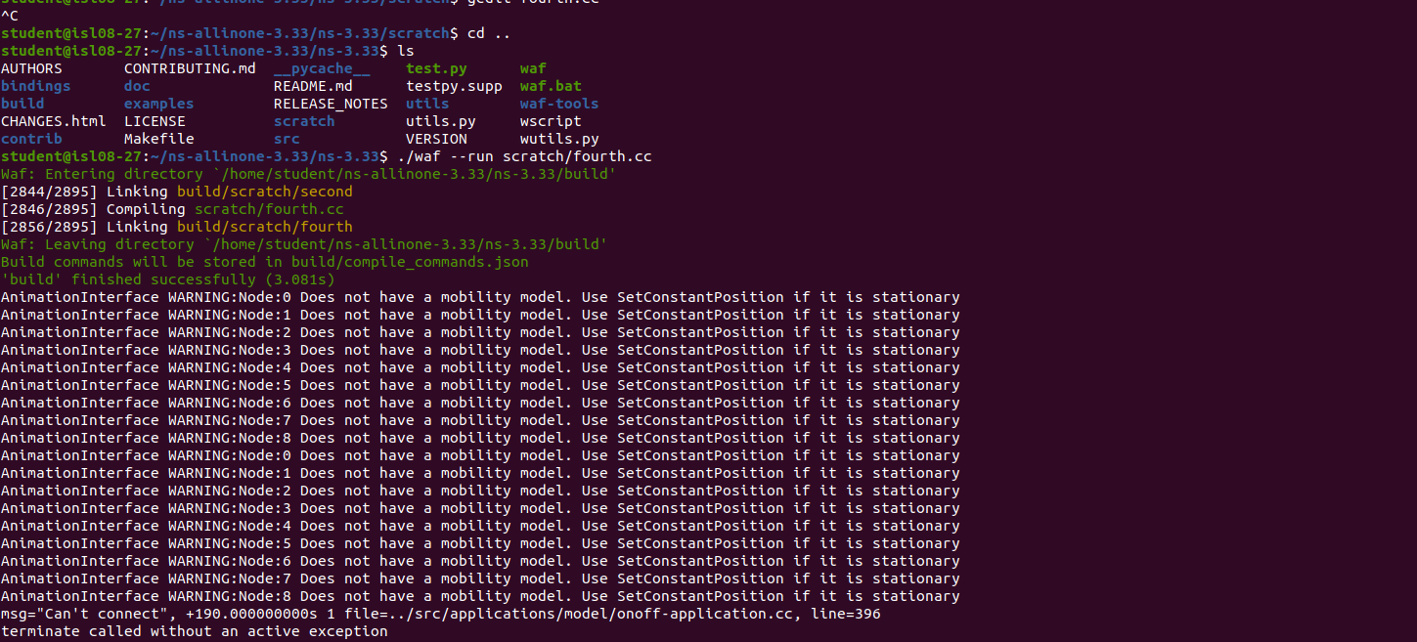

**SIMULATION**

**P.T.O**

